SAURABH CHAVAN

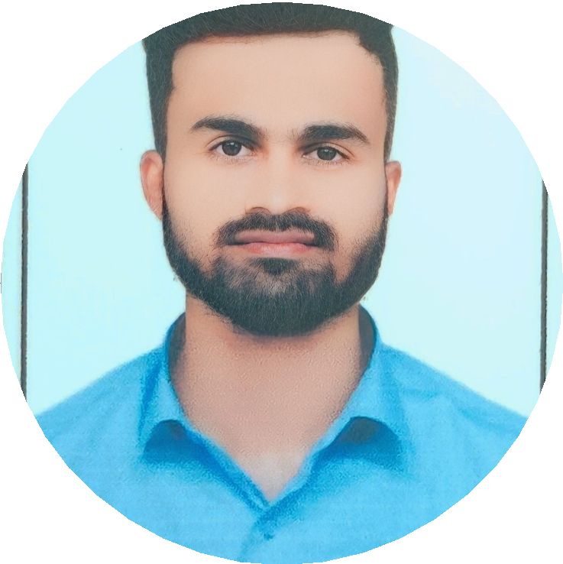

(Software Engineer - EY GDS)

 03/10/2001 (Maharashtra, India)

 Latur, Maharashtra - 413

 [saurabhchavan.official212@gmail.com](mailto:saurabhchavan.official212@gmail.com)

 https://saurabh-212800.github.io/Portfolio//  [www.linkedin.com/in/saurabh-cha212](http://www.linkedin.com/in/saurabh-cha212)

 https://github.com/Saurabh-212800

My name is Saurabh Chavan. I’m a versatile software engineer possessing a broad range of skills and a diverse skill set. I work best in dynamic contexts, whether I’m engaging with designers to improve user experience or embracing agile approaches to produce projects quickly and efficiently.

**EDUCATION**

**WORK EXPERIENCE**

# Bachelor of Engineering

(Electronics and Telecommunication Engineering)

CGPA - 9.03

Dr. DY. Patil Institute of Technology, Pune 

2019 – 2023 

# 12th High School Certificate

PCM Grade - 70.00

Tripura Junior Science College 

2018 – 2019 

# Mars explorer

Mostly playing with Mars rovers to search for the remains of an ancient society

 Mars (Solar System)

 November 2017 – present

# Personal portable heater

Hired on demand by those who happened to feel cold during the day and could use a hug too

 All over Earth

 June 2008 – March 2010

**CERTIFICATIONS**

**SKILLS & LANGUAGES**

# DevOps Engineer Expert (AZ-400)

DevOps, Deployment, Security, Compliance 



https://shorturl.at/agrHQ 

# Computer

 Python++  DeRust

 JavaSharp  Macrohard

# Azure Developer Associate (AZ-204)

|  |  |  |
| --- | --- | --- |
| **Other tools** |  | |
| Mars rover  Ballpoint pen | Asteroid gazer  Signalscope | Brain |

DevOps, Deployment, Security, Compliance 



https://t.ly/rgIpK 

# Languages

 Earthian  Interstellar

 Martian  Nolan

**PROJECTS**

**This LaTeX résumé** Great success in interstellar job applications [ceskergabbro.com/llresume [](https://ceskergabbro.com/llresume)](https://ceskergabbro.com/llresume)

**PERSONAL INTERESTS**



Writing quantum poems Playing the flute

Collecting minerals Building hammocks

[github.com/ceskergabbro/llresume [](https://github.com/ceskergabbro/llresume)](https://github.com/ceskergabbro/llresume)

**The strange look of cats on Mars** A collection of the strangest photos of cats [www.flickr.com/ceskergabbro/catsonmars [](https://www.flickr.com/ceskergabbro/catsonmars)](https://www.flickr.com/ceskergabbro/catsonmars)